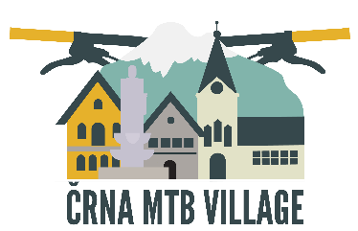

Open call: Photography competition »Črna MTB village« during the ENDURO WORLD SERIES AND BLACK HOLE BIKE FEST 2018
in Črna na Koroškem

This call is open to all professional and hobby photographers. Participation is possible only with photos related to the topic of mountain biking. Each participant can participate with up to five photos per selected topic. Participation in the competition is free of charge.

Theme: Spending Free Time on a Mountain Bike.
Photos should show experiences while spending free time on a mountain bike.

Signups and Photo Submission:
Via wetransfer (www.wetransfer.com, with the e-mail address of the recipient: crna.mtb.village@gmail.com). Minimum size of the uploaded photos: 3,000 pixels per long page (*.jpg; 300 dpi; RGB).

How to Label the Photos?
The photos must be marked with: author's name, serial number with the indication of all works, the title of the photo (example: name, surname, 001-Cycling under the mountain Peca). Amateur and professional photographers can participate in the competition independently of the place of residence and the age group. The competition is organized in accordance with the rules as determined by the organizer. By submitting and confirming the application, participants accept the rules of the competition.
The participant must be the author of all submitted works as well as all copyrights of third parties (persons in the photographs). All photos which will arrive on time will be reviewed and evaluated by an expert jury composed of:
Tomo Jeseničnik – president of the jury
Boris Keber – member of the jury
Alen Odžakovič – member of the jury

Deadline for photo submission: from 25. 4. 2018 to 10. 6. 2018.
The announcement of selected and awarded photographs will take place at the official opening of the exhibition in Črna na Koroškem, 30. 6. 2018 at 18:00. Top 10 photos will be on exhibition from 23.6.2018 at different locations in the centre of Črna na Koroškem.
Authors of the best three photos that will be selected by the professional jury, will receive prize money at the official opening of the exhibition, on June 30, 2018, at 18:00 (1st place 150 €, 2nd place 100 €, 3rd place 50 €).

All information on email: crna.mtb.village@gmail.com

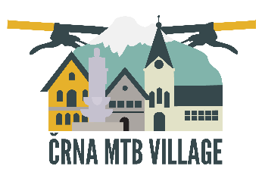
Črna MTB village photo contest

Application form

Name and surname: ___________________________________________________

Address: _____________________________________________________________

Telephone number: ____________________________________________________

E-mail: ______________________________________________________________

VAT number: _________________________________________________________

Applying for the following work:

- ______________________________________________________________

- ______________________________________________________________

- ______________________________________________________________

- ______________________________________________________________

- ______________________________________________________________

Please send a precisely fulfilled application together with all photos
no later than 10. 6. 2018.
By submitting and signing the application, the author agrees and confirms that the organizer of the competition can use his works for the promotional purposes of the competition in all printed media, electronic media, social networks, and projections without prior
permission of the authors and participants or without payment.

Date: __________________ Signature:

